Coursework Report

Zhao Yue

[40413819@napier.ac.uk](mailto:40413819@napier.ac.uk)

Edinburgh Napier University - Modul Title(SET08122)

1. **Introduction**

This time the coursework is to implement a text-based Tic-Tac-Toe (Noughts & Crosses) game using the C programming language. And this report will to be demonstrate through the understanding of both theory and practise in relation to the content of the Algorithms and Data Structures module. The tool I use is Notepad++ and visual studio. Tic-Tac-Toe has nine positions. As long as there are horizontal or vertical or diagonal has three positions are the same kind of pieces, this player wins.

The basic requirements of the course are you need have a Game board. And you can achieve representing the people interacting with the game. And you need have “noughts” and “crosses” of the title. You can also put the pieces in any position you want to place. These basic requirements are all perfectly running. On this basis, some functions have been added, man-machine battles, and two difficulty levels for computer players (two kinds of judgment conditions). When the game finishes showing the winner, you will be asked if you want to come again.... I will introduce these features in the design and explain how they are implemented.

1. **Design**

**Game flow**

After opening the game, you will first get an introduction to the game and how to win, then choose 4 modes, PvP, PvE, quit and set CPlevel. There are two kinds of CPlevel. After setting, go back to the beginning and choose. Two battle modes, after the victory will be asked whether to continue playing.

**Game board**

First of all, I created an area for the game. Since the board is 3×3, I use a 3×3 array matrix to display it. And printf ___|___|___, and put the number in it. Then these pieces will be inserted into a two-dimensional array. The function about this part is “displayBoard” It is used to print a variable gaming area. My game board consists of numbers and "|".

**Print piece**

According to coursework requirements, the pieces and the value should be define as the type of pieces like ‘O’ or ‘X’. After creating the game board, you can print on it. Two-dimensional arrays are also set up at the beginning. Then use the while, if, if...else, while, do...while to judge the victory condition.

**Judge**

I use function-selectLocation to judge whether the player win(PvP or PvE). First of all, through calculation, we know that there are six situations in which the player wins. In this part, use while(1) to run automatically, using if, while, if...else and other statements to achieve the judgment. After returning the value entered by the player, the conditional statement begins to judge, and the statement is judged by constantly comparing until there is a condition that matches the victory. If you insert "noughts" or "crosses" into all nine positions and have not met the victory condition, then declare it as cat game.

**PVE**

In the initial options, you can choose PvE (CP), which is to play against the computer. There are two levels here. The first is to randomly select a coordinate in the executable coordinates. Since there have been six conditions for judging how to win, the second level, in addition to randomly generating coordinates, it will prevents the player from meeting the six winning conditions. In the statement set in advance by the computer, the AI(rand) will automatically generate coordinates.

**Others(about algorithm and data structure…)**

This section will give an overview of the parts not mentioned above. Here we will start with the code and mention some algorithms and data structures.

At the beginning of the code, I create an array initArr. And create a boardArr in the main function. BoardArr holds the data on the board. Then, I need to reset board. And set the" usedLocation" in each section to hold all the location already used to prevent the user to overwrite on the board. In the next section, which player will choose, I uesd “turn” to used to verify what user is playing. When turn is odd, it is the P1 turn to play; when turn even it is P2 or CP turn to play. Of course, every time the player enters a value, it will make a decision. If the input option does not meet the requirements, it will prompt "invalid selection..Please try again". Here we need to explain the following input modes for the game. After using the array, there are two input modes. The first one allows the player to enter coordinates, and the second is to display each coordinate to a digital display of 1~9. I chose the second one, because the principle is the same, the latter allows the player to know more clearly and clearly where it will be. In function “selectLocation”, “getAILocation” I used a pointer.

In the end, if you want to start a game again, selecting "y" will return you to the beginning of the game.

1. **Enhancements**

In this coursework, I have some features that can be added and improved. For example, there is no revocation and playback function as stated in coursework. Because the foundation of the C language is not good, and the English is not good, it is very slow when reading the textbook. If I have more time, I will add these two features and add the input of the name as well as some other more humane features. And I can talk about the interface to beautify some.

1. **Critical Evaluation**

My game has completed all the basic functions required in coursework, and the extra features are also working perfectly. Some of these completed features were learned from the additional online materials provided by the teacher, some of which I found on baidu or google. I think the lack of code is the part of the code that sets the computer level in the man-machine battle. Although there are some differences between the two levels, the difference is not very large, especially in 3×3, I will implement it in other larger chess versions in the future.

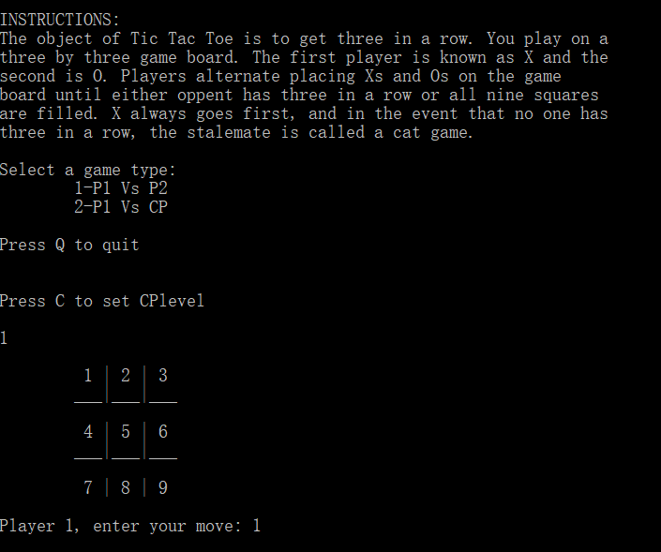 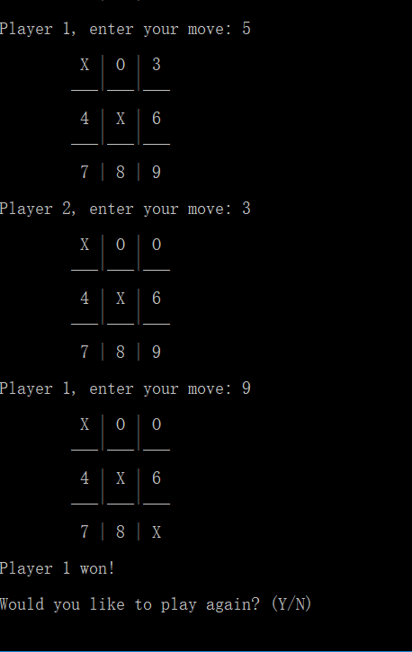

1. **Personal Evaluation**

In this coursework, I have learned a lot of knowledge, because I didn’t do much learning about C language before, so I can learn the c language again this time. I learned algorithms and data structures, but this time I learned more about logical operations. Now I can use it very well. But there are also many difficulties in the learning process, the foundation of the c language is not good. And the English foundation is not good, so it took me a lot of time to read the textbooks and online materials. Even so I still have a lot of problems not solved, like the fallback function and the playback function. There are still some functions that I can achieve with my own efforts. At the beginning, I searched for information on the Internet. When there were some unresolved questions, I asked my classmates and teachers. In general, the coursework is ok. Through this study, I know what can continue to work and I need to continue learning.

1. **References**

Some pictures:

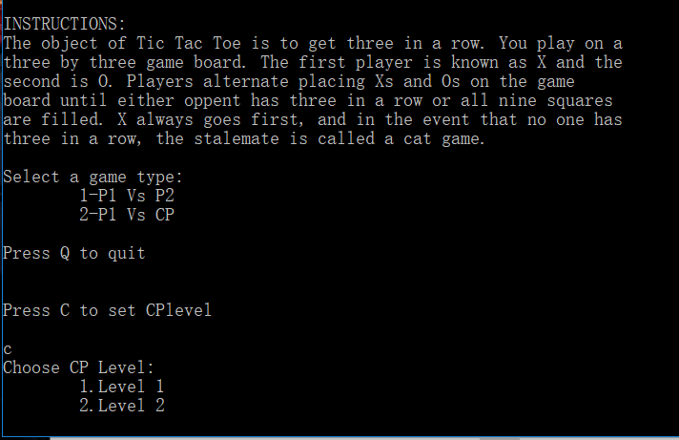 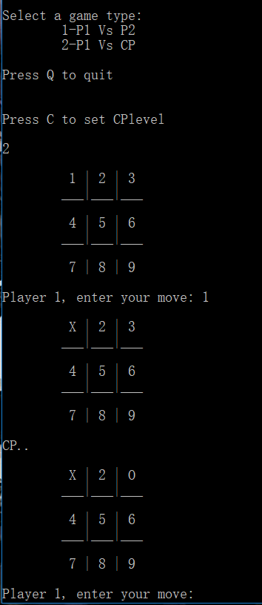

1. <https://blog.csdn.net/constantin_/article/details/79575638>
2. <https://www.baidu.com/link?url=p2AZ4y9jsfLCwHkDc4TKQf2GnajSL2xphGt-RHeOdkwT_R1ejyojaTt5fmBJRpHY&wd=&eqid=c10e74ea00061e27000000065c9af9f7>
3. https://www.baidu.com/link?url=p2AZ4y9jsfLCwHkDc4TKQf2GnajSL2xphGt-RHeOdkwT_R1ejyojaTt5fmBJRpHY&wd=&eqid=c10e74ea00061e27000000065c9af9f7